EXERCISE 4, INHERITANCE – GETTING STARTED

# Exercise 4, Inheritance – getting started

## Objective

The primary objective for this lab is to enable you to derive new types and to add specialist functionality.

## Overview

The lab introduces some of the basic concepts of the inheritance story. As mentioned in the associated session, in order to implement inheritance, you must first have a class that provides the fundamental definition or behavior you need. In this lab we will play about with circular shapes.

This practical will be built on two chapter’s time.

### Step by step

1. Open the Labs project and then add a new package called lab04.
2. Create a new class called Program with a main() method in the lab04 package
3. Create the following class structure  
   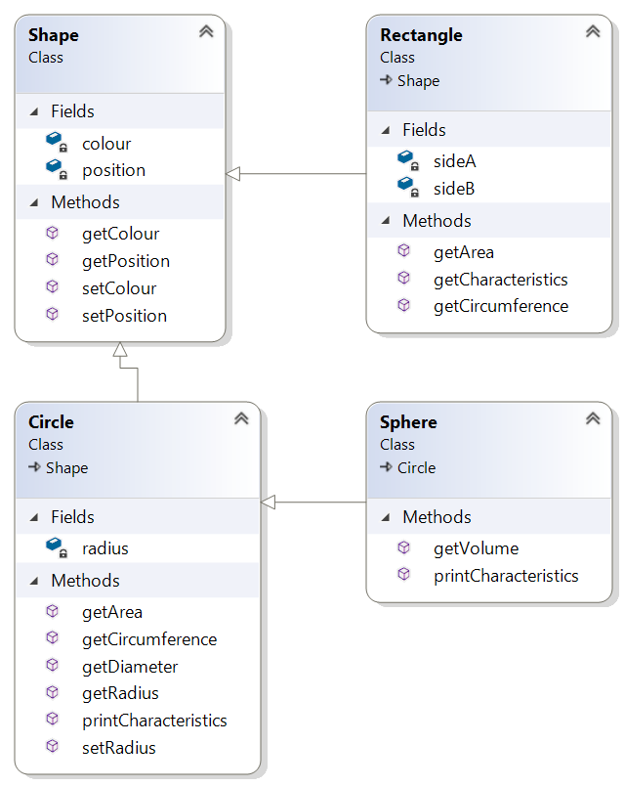
4. Create a constructor for Shape to set its colour and position
5. As you can see, **Circle** extends **Shape** and **Sphere** extends **Circle.**
6. ***Position*** is of type **Point** which is a class with built-in x and y.
7. ***Colour*** is of type **java.awt.Color**

Tip: Use **Math.PI** to get the value of **PI**.   
You will need this to calculate the area and circumfrance of circle.

Volume of an sphere is calculated as 4/3 * PI * R^3 (R to power of 3)  
You can use the Math.pow() fuction or R * R * R

1. Create getters and setters for each of the fields (colour, radius…) as indicated in the class diagram above.
2. The **getCharacteristics()** method returns a *String* containing all the attributes of the shape. It will be up to the caller how to display this information.
3. Create a few shape type in main().
4. Print the characteristics of the Rectangle, Circle and Sphere objects which you've created.
5. Create an ArrayList<Shape> called **shapes** in the main()
6. Add the shapes which you created earlier into the *shapes* ArrayList.
7. Create an enhanced **for** loop to scroll through each shape and print its colour and position (x,y).  
     
   How does this work?! How can we store a shape like Rectangle in a list of Shapes? All will be revealed in the next chapter.

** End **